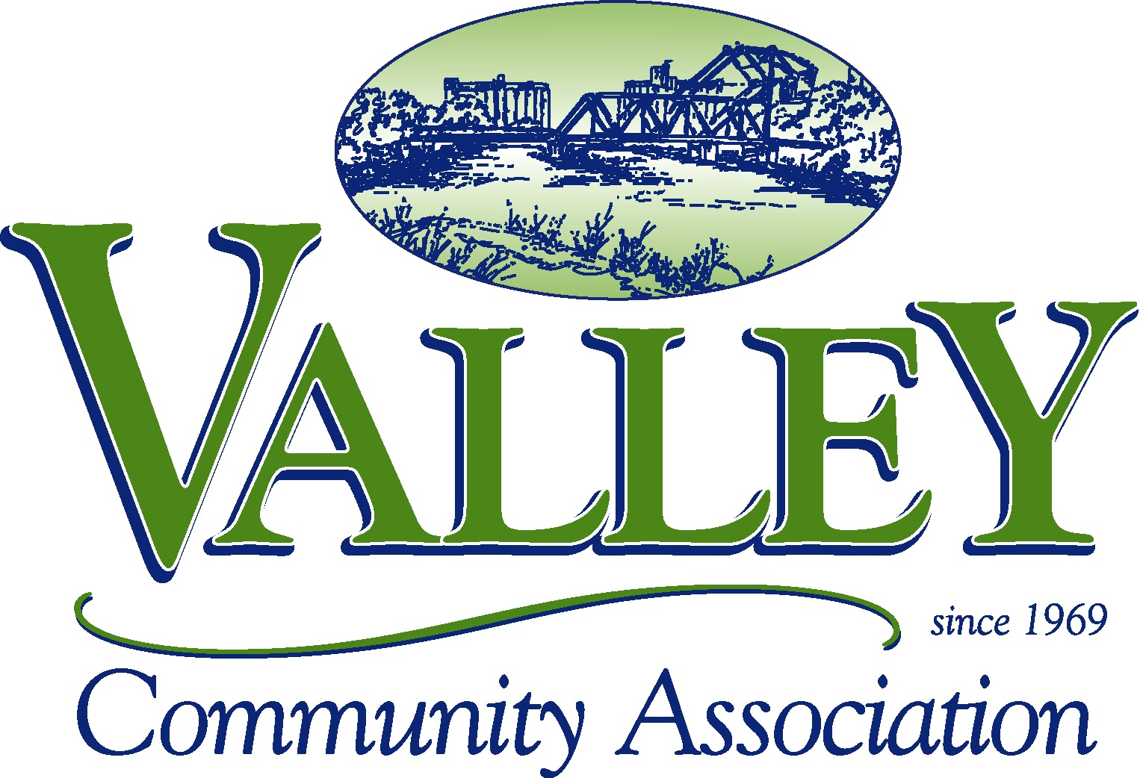

Attention PARADE PARTICIPANTS!

A representative from each parade contingent MUST attend a pre-parade meeting on

TUESDAY, MARCH 4th at 6:30pm at the
Valley Community Center.

Parade rules, regulations, etc. will be discussed. Parade line up packets and vehicle passes will be handed out.

If a representative from your group does not attend, your group will not be allowed to participate in the parade.

Thank you in advance for your cooperation.
Any questions or concerns about the meeting can be directed to
Denise: 716-823-4707 ext. 4 or denise@thevalleycenter.com

